ISWE209L - Data mining
Assignment Report
Submitted by

23MIS1117 – Anuhya Arun
23MIS1017 – Pooja Narasimhan

Indoor Localization using Geo-Magnetic Field and WLAN Data with Health Monitoring

https://github.com/Anuhya-Arun/DataMining_IndoorLocalization



School of Computer Science and Engineering
Vellore Institute of Technology, Chennai
Nov 2025
Index

S.No | Description | Page
1 | Introduction | 3
2 | Objective | 3
3 | Scope of the problem / Outcome | 3
4 | Literature Survey | 4
5 | Methodology | 7
6 | Outputs and Results | 12
7 | Conclusion | 20

Indoor Localization using Geo-Magnetic Field and WLAN Data with Health Monitoring

- INTRODUCTION
Indoor localization is an emerging technology to effectively track human motion in complex indoor environments with a range of applications in smart infrastructure management, assisted living, and monitoring of patients. This project will advance the field of indoor localization by proposing a multi-modal ensemble approach that fuses sensing modalities (WiFi, geomagnetic, and inertial sensor data) with advanced model fusion approaches to improve accuracy and robustness against indoor problems.
This system employs two combinatorial architectures, a Hierarchical Clustering Tree (HCT) Fusion model and an RF Dominant ensemble. The HCT Fusion model is a hierarchical ML structure, in general terms, each node partitions the feature space through clustering and uses specialized classifiers to predict room transitions and time taken to traverse. The HCT Fusion model achieves an individual accuracy of 91.4% outlining strong discriminative capacity for prediction of spatiotemporal movements. The RF Dominant ensemble relies on the fused aggregation of multiple Random Forest classifiers informed and bolstered with feature importance weighing (α= 0.3), contributes a 91.73% accuracy at stand alone application.
The HCT Fusion and RF Dominant models are combined in the ensemble to take advantage of both models' strengths, with the fine-grained hierarchical representation provided by HCT and generalization under sensor noise and variability enabled by RF. The performance and spatial resolution predictions, as projected, are improved with this ensemble extension together with improved prediction stability under controlled testing conditions for overall accuracy in the ranges of 94 - 97%.
In addition to localization, health-aware mobility monitoring is incorporated, which provides an analysis of deviations from predicted traversal time, and early detection of key indicators for familiarity, fatigue, imbalance, or other health deviations. Continuous deviations in walking speed, or other movement patterns will be the basis for detection and mitigate potential mobility impairment to expedite intervention. Overall, the HCT - RF Ensemble Localization Framework demonstrates a method for robust localization, adaptive prediction, and combined wellness monitoring, resulting in a system with potential localizing capabilities for next-generation adaptive smart environments such as hospitals, elderly care facilities, and smart buildings.

- OBJECTIVES
The main goals of this project are as follows:
1. To develop and validate a powerful multi-model ensemble framework that merges predictions from Hierarchical Clustering Trees (HCT) and Random Forests (RF) to increase the prediction accuracy and reliability of an individual's next room transition in indoor settings.
2. To create a travel time estimation module that effectively predicts how long it will take for a person to move between locations based on regression models trained on heterogenous sensor data.
3. To create a real-time health monitoring component that compares predicted and actual movement times, which automatically detects outliers, and monitors user status as "Normal," "Slight Delay," or "Needs Help," helping with the early detection of abnormal mobility or distress patterns.

- SCOPE OF THE PROBLEM / OUTCOME
This project encompasses not only conventional indoor localization, but also smart, context aware tracking and health monitoring in complex environments. The traditional systems are limited to providing coordinate estimations (X, Y) and little insight as to where your movements will take you next. This project innovates on existing systems by providing insight into your future movements - for example, next room and an estimate of time to get to the next room - in conjunction with fusing WLAN and geomagnetic sensor output.
However, our goal is to offer a more comprehensive analysis and analytic framework for interpretation that is not only high spatiotemporal in nature, but also infers the user's well being. The project is intending to offer:
- A real time, mixed model ensemble system that outperforms all models individually.
- Health aware localization system that predicts future room level movements and is able to provide insight into well being.
- A working prototype that can function in real world environments, providing the end user with two outputs:
- Prediction of next room, and time estimate of movement.
- Automatic classification on health status.

- LITERATURE SURVEY
Although sensor fusion and computer vision techniques are still developing, there exists indoor localization capability using purely fingerprinting modalities. Systems nowadays will incorporate PDR, Wi-Fi, and magnetic field pressure with CNN object recognition for reliable and context-aware localization. Fingerprinting approaches are adept at offering performance that mitigates ambiguities based on sparsity of environmental data and environmental techniques for spatial awareness, employing image semantics and probabilistic modeling of movement. Particle filtering remains a significant concept to produce a unified position analysis model of many heterogeneous fingerprints which ultimately leads to enhanced precision and flexibility in navigating indoor spaces.
Indoor positioning systems have received far more attention as alternative solutions to GPS for indoor environments characterized by limited satellite signals. Several modalities have been analysed including WLAN, ultrawideband, RFID and camera-based systems, but especially attractive are smartphone-based Pedestrian Dead Reckoning (PDR) systems that use onboard sensors, such as accelerometers, magnetometers or gyroscopes, that do not require any external infrastructure. The traditional methods for step detection take advantage of accelerometer readings via peak or zero-crossing methods, whereas heading estimation relies on either magnetometers or gyroscopes. Each of these sensors can suffer from interference or drift which results in poor performance. Sensor fusion methods such as Kalman filters or unscented Kalman filters have been used to reduce the negative impact of interference and drift by combining complementary sensor readings. However, maintaining high long-term accuracy in position remains difficult owing to sensor drift.
There has been a considerable amount of work and literature surrounding the research into indoor localization systems, specifically with respect to overcoming the drawbacks of GPS and applying hybrid solutions using aspects of both Wi-Fi and inertial sensors. Inertial methods of localization such as Pedestrian Dead Reckoning (PDR) methods are based on estimating steps and changes in heading, but can also suffer from drift over time, while Wi-Fi signal weak-signal or not available in indoor environments signal fingerprinting and trilateration localization methods also have irregular Wi-Fi signal issues. Some research has looked at multi-sensor fusion, using Kalman filters, Extended Kalman Filters, and Particle Filters, and some group of fusions to address issues of drift and reliability which can improve accuracy of sensor-based localization methods. Hybrid systems have also been proposed that have helped support both trilateration and signal fingerprinting localization equipment, taking advantage of the complementary benefits from each type of localization. Nevertheless, these hybrid systems and methods still tend to not provide reliably accurate localization, which is a major limitation when indoor localization environments and wireless signal propagation can change from space to space and over time. Future research and studies will deepen the research into adaptive fusion algorithms to resolve the drift and reliability issues with complex indoor environments.
Indoor localization has evolved by utilizing advances in sensor integration and deep learning methods, in response to issues associated with traditional Wi-Fi fingerprinting, including signal instability and device dependency. The introduction of geomagnetic field information has improved stability, despite having variability related to the types of sensors. More recently, some studies have integrated visual scene recognition through deep convolutional networks to improve localization capabilities through environmental understanding. Hybrid systems that utilize Wi-Fi in combination with either magnetic or visual information have demonstrated improved accuracy in indoor localization. While hybrid approaches improve localization accuracy, the interdependence of computational complexity, energy consumption, and susceptibility to environmental change still pose significant issues. Driven by deep learning, the ability of data fusion systems to allow for real-time position estimation indoors, at scale, and potentially across heterogeneous devices, is promising.
Indoor localization research has expanded to include Wi-Fi, Bluetooth Low Energy (BLE), visual markers, and inertial sensors. Wi-Fi fingerprinting produces highly accurate results, but it takes time to calibrate the environment for accuracy. BLE provides the advantage of low operational power but at the cost of the stability of the signal. Inertial sensors give continuous tracking capability, but they add up errors over time. A multi-source fusion framework that fuses these modalities to produce robustness has emerged as the most used strategy, whether using Kalman or Particle Filters. Techniques such as landmark-assisted localization using BLE beacons or QR codes have also been used to improve accuracy through the reduction of PDR drift. Moreover, the evaluation of machine learning models, specifically multilayer perceptrons, have also improved trajectory prediction accuracy. However, scalability and generalizability of the models across environments is still a significant limitation.
Indoor localization remains a research topic of interest because GPS does not work well in enclosed spaces. Wi-Fi received signal strength indication (RSSI) localization has been the most common method, mostly due to it being cheap and easy to deploy. The biggest drawback of Wi-Fi RSSI is that it is sensitive to signal fluctuation (law of large numbers) and multipath propagation (refraction patterns). Early successes in localization were with more traditional models, such as k-nearest neighbors (KNN) and Kalman filters. Nowadays, deep learning approaches, especially convolutional and artificial neural networks, have improved robustness and resiliency to variations in noise. Some researchers have also attempted to tackle the problems of RSSI-based localization by using Continuous Wavelet Transform (CWT)-based fingerprinting and hybrid RSSI-Coding Sophisticated Interference (CSI) techniques to extract richer sets of features. The caveat remains that most models proposed in the research literature require large labeled datasets with high computational requirements, hence the greater motivation for progressing to more data-efficient forms training and data augmentation. This tension of model complexity and performance is likely to remain relevant among future interests in the field of indoor localization technologies.
When multiple individuals are to be localized indoors, new challenges emerge related to the escalation aspects of distinguishing individuals and scalability. Early systems depended first upon the users themselves wearing devices or survey systems that necessitated dense sensor grids in practical use. Even Wi-Fi fingerprinting can achieve reasonable accuracy, but it is susceptible to changing environmental dynamics. In addition, the so-called "device-free localization" that relies upon the perturbation of radio signals also has issues differentiating between occupants that overlap in space. There has been several recent systems that take advantage of combining passive infrared (PIR) motion sensors with Bluetooth Low Energy (BLE) beacons to permit the combination of named and anonymous occupants to be localized simultaneously. This hybrid form of localization is a likely solution to achieving accurate and private multi-occupant and person localization as part of smart homes and health monitoring applications.
Localization based on fingerprinting has traditionally been a popular option due to the lack of infrastructural dependency that uses Wi-Fi and magnetic field data for mapping purposes. Unfortunately, lengthy calibrations make this option difficult to scale. PDR (pedestrian dead reckoning) integrated with CNN (convolutional neural networks)-based scene recognition has improved robustness by fusing inertial and visual information simultaneously. Particle filtering frameworks can also improve accuracy by integrating environmental constraints into the process. Utilizing Wi-Fi, PDR and visual features, wi-fi based positioning can provide fine-grained localization of complex indoor environments while also providing semantic scene understanding in conjunction with spatial tracking.
Research on smartphone-based indoor localization has shown that no sensing modality is universally effective across all environments. Wi-Fi and BLE systems have poor consistency due to signal instability, while PDR systems can accumulate drift and need to be recalibrated at every opportunity. Vision-based approaches such as SLAM reduces signal reliance, but these approaches require significant computational resources. Fusion approaches that employ either Kalman or particl filters combine inertial data with wireless for a suitable balance for accuracy and efficiency for hybrid systems. Hybrid systems effectively use wireless signals to achieve absolute positioning while leveraging PDR with wireless signals for relative motion estimates, making them robust for superior and effective results in dynamic and cluttered indoor spaces.
Machine learning has become increasingly applied to indoor localization in order to increase adaptability of models and robustness. Inertial measurement unit (IMU)-based systems with the additional inputs from neural networks can account for real-time drift correction and user trajectory prediction. ANN filtering techniques improve heading and step-length assessments by diminishing the negative impact of noisy sensors. Likewise, deep learning has been utilized in fingerprint matching and trajectory prediction. However, many of these systems remain static, defined by their lack of adaptive feedback systems that can retune parameters within the environment and system in real time. New systems have emerged which can illustrate adaptive learning modules which continuously optimize the prediction model as more environmental feedback is provided, demonstrating a major shift toward introspective intelligent indoor localization.
Wi-Fi-based indoor localization schemes generally fall under the categories of fingerprinting or time based. Essentially, fingerprinting schemes rely on offline radio maps while time based schemes, such as Round-Trip Time (RTT), focus on estimating distance based on the delay of propagation delay. Hybrid models which utilize both the received signal strength indicator (RSSI) model and RTT models offer some mitigation for multipath and non-line-of-sight issues; however, most models utilize naive feature concatenation as they don't leverage such advances into a proper model or enhance overall performance. Recent work continues to examine deep fusion frameworks, such as Canonical Correlation Analysis and multimodal neural networks, used to model the two modalities together and increase the spatial accuracy and robust of the signals.
Pedestrian Dead Reckoning and Wi-Fi fingerprinting are two of the most well-established localization modalities but are limited by drift in PDR and environment variability in Wi-Fi. Early fusion methods that combined signals utilized Kalman and Particle Filters, and relied on fixed parameters. Deep learning has introduced more adaptive models - LSTMs were applied for successive motion prediction, while DNNs were used to model signal strength predictions (RSSI). Deep learning also enabled more end-to-end learning of spatial structures over time. However, even with the advances in deep learning, most systems still under-leverage the cross-modal relationships of two modalities, and have plenty of room to utilize more complex hierarchical fusion structures that incorporate temporal, spatial, and contextual relationship.
Indoor localization algorithms designed using time-based and fingerprinting methods have started to reach maturity, but accuracy is still ultimately defined by variations in signal reception and multipath interference. Robustness has increased with the inclusion of deep learning models trained using data from both RSSI and round-trip time (RTT). Hybrid deep learning models that use Deep Canonical Correlation Analysis show strong correlations between modalities to produce better location estimates. Multimodal localization solutions demonstrate how jointly learned feature spaces perform superior to traditional fusion with connections based on a common signal stream, leading to equal, efficient, and even real-time multimodal localization accuracy.
Inertial-based approaches to indoor localization typically rely on Inertial Measurement Units (IMUs), but both noise and the accumulation of drift limits their usefulness. Inertial Measurement Units (IMUs) have traditionally relied on Kalman filters to address these errors, however static parameters also impair their ability to adapt to changing environmental conditions. Several have attempted to address this challenge in the past using ANN augmented fusion systems to dynamically tune these filters while learning to predict and correct biases from sensor errors in real time. More recently, hybrid architectures with ANN estimators plus either fuzzy logic or adaptive filtering schemes have yielded magnitudes of accuracy improvement when predicting trajectories. The notion of learning-to-predict, therefore indicates the beginnings of promising evolution of intelligent and self-correcting localization pipelines.
Multivariate time-series forecasting furthers advances in indoor movement trajectory forecasting and extends to applications such as traffic and power analytics. Many traditional models exist, such as VAR or Gaussian Processes, but these models cannot model the complexities of temporal dependence, necessitating an exploration of deep learning architectures including recurrent networks (RNNs), Long Short-Term Memory (LSTM) or temporal convolutional networks. All of these architectures often miss intra-variable dependence. Learning inter-variable dependence using Graph Neural Networks has recently been shown to model spatial and relational information learned between sensor signals leading to increased accuracy in multivariate forecasting, and are relevant for human trajectory and time prediction in indoor environments.
Indoor positioning has gained increased relevance due to the potential importance it might have in navigation, augmented reality, and emergency response systems, especially because GNSS (Global Navigation Satellite Systems) is not effective indoors. The earlier work primarily had a focus on using wireless signals, such as using signal types, e.g. Ultrawideband, WLAN, cellular, and predominantly focusing on use of Received Signal Strength Indicator (RSSI) methodology. However, researchers had issues with multi-path and alignment. To address these issues researchers later examined technique of multisource information fusion technology, which merges various signal data (Wi-Fi, Bluetooth, smartphone sensors). With machine learning methodology e.g. K-Nearest Neighbors, Support Vector Machines, neural networks, researchers were able to improve localization accuracy with modeling of complex RSSI data. Recent work has shown researchers combining visualization and deep learning (such as CNN) techniques, and every source of raw data, is becoming more accurate for indoor situations in sense and fusion frameworks.

- METHODOLOGY
5.1 Multi-Modal Ensemble Overview
This study proposes a multi-modal ensemble learning approach that combines the WiFi and sensor-based prediction (Random Forest Dominant Model) with visual scene understanding (Hierarchical Clustering Tree Visual Model) in order to improve indoor localization accuracy and robustness through confidence-weighted fusion of heterogeneous data streams.
The ensemble consists of two supporting modalities:
- RF-Dominant (WiFi + Sensor): A dependable spatial prediction model showing a baseline accuracy of 91.73%.
- HCT-Visual (CCTV/Images): Visual recognition model using convolutional neural networks for room classification and verification.
System Architecture and Data Flow
The system has a continuous data acquisition and fusion pipeline which includes the following inputs:
Raw Data Streams:
- WiFi and Sensor Data (100 Hz) — including 120 WiFi access point RSSI values, 9-axis IMU data (accelerometer, gyroscope, magnetometer) and timestamps.
- Visual Data (1-5 Hz) — including CCTV frames, detected person crops, and temporal information.
Processing pipeline: Data acquisition → Feature extraction → Model inference (RF + Visual) → Fusion → Final Room Prediction
The fusion engine merges the probabilistic predictions from each modality according to the confidence levels of the models and produces the final room prediction with confidence scores.

5.2 Visual Model Development Methodology
5.2.1 Data Preparation
- Frame Extraction: One frame is extracted from the recorded video file every second, and the frame is then labeled manually as Room_ID, bounding box, and confidence.
- Preprocessing: Person detection performed isolates relevant object regions, which are then cropped to the bounding boxes with a 20% margin. All images will be resized to 224 x 224 x 3, normalized with ImageNet statistics, and optionally temporally stacked to incorporate motion cues.
- Augmentation: To increase the diversity of the dataset, rotation (±15°), brightness (±20%), and horizontally flipping augmentation are applied.
- Dataset Split: The data is split into 70% for training, 15% for validation, and 15% for testing.
5.2.2 Model Architecture
The Hierarchical Clustering Tree Visual Model (HCT-Visual) utilizes a CNN backbone for visual feature extraction and hierarchical decision making:
- Base architecture: EfficientNet-B3 pre-trained on ImageNet, to transfer the features of the pretrained model to our related linear task
- Head consists of:
- Global Average Pooling layer
- Dense(512, ReLU) → Dropout(0.5)
- Dense(256, ReLU) → Dropout(0.3)
- Dense(10, Softmax) for ten categories of rooms
- Output: probability distribution across all room categories, [p₁, p₂, …, p₁₀].
5.2.3 Training Strategy
- The model training process occurs in two steps:
- Phase 1 is feature extraction. The backbone layers are frozen, so only the classifier head is trained for 20 epochs, utilizing the AdamW optimizer (learning rate = 1e−3).
- Phase 2 is fine-tuning, where the last 30% of the backbone layers are unfrozen, and the model is fine-tuned in an end-to-end manner with lower learning rate (1e−5) for 40 epochs.
- Optimization Setup:
  - Loss: Categorical Cross-Entropy
  - Scheduler: ReduceLROnPlateau
  - Early Stopping: patience = 10 epochs.

5.3 Multi-Modal Fusion Methodology
5.3.1 Confidence-Based Fusion
The fusion engine will apply adaptive weighting based on model confidence between RF and Visual predictions:
- When the visual confidence is > 0.85 and the RF confidence is < 0.70 then the fusion engine will assign the visual prediction a higher weighting (weight: visual=0.7, RF=0.3).
- When the RF confidence is > 0.85 and the visual confidence is < 0.70 then the fusion engine will assign the RF prediction a higher weighting (weight: RF=0.8, visual =0.2)
- When both predictions provided a confident prediction and the predictions were in agreement, the fusion engine will assign equal weightings to both predictions (weight: 0.5 each).
- When both predictions are uncertain, the fusion engine will assign the default weightings (RF=0.7, visual=0.3).
Final prediction probability calculated as:
$$P_{fusion}=w_{rf}×P_{rf}+w_{visual}×P_{visual}$$
where $w_{rf}$and $w_{visual}$are dynamically adjusted fusion weights.
5.3.2 Temporal Consistency Module
A Temporal Smoother uses confidence-weighted majority voting over a sliding window of the last five predictions to achieve stability across frames. The smoothed prediction will represent the room with the highest overall confidence, promoting temporal consistency and reducing flicker between successive frames.

5.4 Implementation Methodology
5.4.1 Phase 1: Individual Model Optimization (Weeks 1–6)
- Gather and categorize over 500 photos for each of the rooms.
- Create person detection and augmentation pipeline.
- Train and evaluate HCT-Visual model based on CNN.
- Retrain and validate RF-Dominant model with new data.
5.4.2 Phase 2: Fusion System Development (Weeks 7–10)
- Create an adaptive confidence-weighted fusion algorithm.
- Add temporal smoothing and conflict resolution logic.
- Perform synchronizing tests with the visual and real-time sensor data.
5.4.3 Phase 3: Deployment and Validation (Weeks 11–13)
- Deploy a prototype in controlled indoor testbed.
- Quantify performance, latency, and failure recovery performance.
- Optimize the model inference efficiency via quantization and prunning.

  - Dataset Description
5.5.1 Image Data





5.5.2 CSV data
Timestamp Current_Room WiFi_AP1 WiFi_AP2 WiFi_AP3 WiFi_AP4 WiFi_AP5 WiFi_AP6 WiFi_AP7 WiFi_AP8 WiFi_AP9 WiFi_AP10 WiFi_AP11 WiFi_AP12 WiFi_AP13 WiFi_AP14 WiFi_AP15 WiFi_AP16 WiFi_AP17 WiFi_AP18 WiFi_AP19 WiFi_AP20 WiFi_AP21 WiFi_AP22 WiFi_AP23 WiFi_AP24 WiFi_AP25 WiFi_AP26 WiFi_AP27 WiFi_AP28 WiFi_AP29 WiFi_AP30 WiFi_AP31 WiFi_AP32 WiFi_AP33 WiFi_AP34 WiFi_AP35 WiFi_AP36 WiFi_AP37 WiFi_AP38 WiFi_AP39 WiFi_AP40 WiFi_AP41 WiFi_AP42 WiFi_AP43 WiFi_AP44 WiFi_AP45 WiFi_AP46 WiFi_AP47 WiFi_AP48 WiFi_AP49 WiFi_AP50 WiFi_AP51 WiFi_AP52 WiFi_AP53 WiFi_AP54 WiFi_AP55 WiFi_AP56 WiFi_AP57 WiFi_AP58 WiFi_AP59 WiFi_AP60 WiFi_AP61 WiFi_AP62 WiFi_AP63 WiFi_AP64 WiFi_AP65 WiFi_AP66 WiFi_AP67 WiFi_AP68 WiFi_AP69 WiFi_AP70 WiFi_AP71 WiFi_AP72 WiFi_AP73 WiFi_AP74 WiFi_AP75 WiFi_AP76 WiFi_AP77 WiFi_AP78 WiFi_AP79 WiFi_AP80 WiFi_AP81 WiFi_AP82 WiFi_AP83 WiFi_AP84 WiFi_AP85 WiFi_AP86 WiFi_AP87 WiFi_AP88 WiFi_AP89 WiFi_AP90 WiFi_AP91 WiFi_AP92 WiFi_AP93 WiFi_AP94 WiFi_AP95 WiFi_AP96 WiFi_AP97 WiFi_AP98 WiFi_AP99 WiFi_AP100 WiFi_AP101 WiFi_AP102 WiFi_AP103 WiFi_AP104 WiFi_AP105 WiFi_AP106 WiFi_AP107 WiFi_AP108 WiFi_AP109 WiFi_AP110 WiFi_AP111 WiFi_AP112 WiFi_AP113 WiFi_AP114 WiFi_AP115 WiFi_AP116 WiFi_AP117 WiFi_AP118 WiFi_AP119 WiFi_AP120 WiFi_AP121 WiFi_AP122 WiFi_AP123 WiFi_AP124 WiFi_AP125 WiFi_AP126 WiFi_AP127 Geomag_X Gyro_X Acc_X Geomag_Y Gyro_Y Acc_Y Geomag_Z Gyro_Z Acc_Z Next_Room Next_Time
21:55.5 4 -52.55942656 -61.20682653 -58.08046518 -55.47389638 -56.79143371 -56.6457925 -53.73790469 -54.16953985 -55.25871088 -60.78898452 -56.72655684 -59.5312937 -54.25850284 -55.96280138 -53.30902457 -51.38100056 -51.606134 -49.78731297 -59.14240397 -54.03821304 -57.34264459 -51.30608173 -54.04604986 -52.79392623 -56.80013915 -55.39699512 -52.80260552 -55.51612704 -59.03412841 -49.99790799 -61.28958791 -51.08816169 -56.44967187 -57.45534122 -54.8332557 -59.40082529 -54.42992462 -46.54472451 -49.36862234 -60.08408738 -54.78672561 -58.19748741 -53.94707278 -58.36230603 -50.83771581 -54.7128008 -58.21178936 -57.10027538 -57.73422787 -56.60400947 -59.50882806 -57.79557792 -51.99293848 -54.72767435 -61.76753607 -53.71330021 -55.67133713 -57.11528926 -60.06092282 -57.32297967 -57.47845764 -56.45606471 -60.42361954 -55.62080543 -54.10474927 -55.83025329 -52.60421577 -60.63955285 -50.87232536 -53.29516737 -55.34095384 -56.38901735 -56.5840745 -51.90626465 -53.89547434 -56.20148809 -63.17701886 -56.61408336 -58.35762791 -56.2548337 -55.27596804 -52.41847395 -59.84623341 -58.5028597 -53.35265419 -51.77045631 -54.00635098 -55.62593622 -56.7679978 -55.65142982 -52.45527874 -56.76732565 -53.71168434 -55.68521068 -54.85043479 -53.99856715 -55.2630404 -56.12627613 -53.2936055 -57.34131309 -55.61505098 -54.6968617 -58.90713223 -51.63210995 -57.34804112 -56.18875486 -60.65334686 -53.0141772 -50.58315056 -59.95886481 -58.84787813 -56.21821664 -57.15611794 -57.10158614 -61.54418574 -57.40676781 -50.20175673 -57.21806057 -50.75156117 -58.51386478 -53.94879074 -59.76427937 -55.63452791 -55.14803216 -58.36016089 -56.08455327 -60.05534692 31.44732805 0.033624779 0.095546441 22.33424785 0.03940623 0.063386991 51.97300869 0.023881726 9.867279186 5 19.69416644
40:00.5 6 -50.54950794 -53.05944898 -51.94987367 -52.76897705 -54.17880147 -58.92809508 -56.56093473 -51.1936791 -57.54087428 -54.06132528 -56.59916221 -54.38425041 -54.94037807 -53.31383553 -55.58576744 -54.67632814 -54.32647531 -53.87042 -51.81085205 -52.57547932 -53.54917583 -54.41860871 -59.28650642 -49.69588068 -54.58165988 -56.72443786 -52.3149848 -55.12405201 -47.46794042 -53.66983789 -52.75781012 -54.67423463 -56.83568595 -55.12898537 -54.24952269 -52.95832569 -52.23190209 -50.7183833 -62.70675293 -54.32480459 -47.61484959 -56.37008917 -50.16654817 -59.23608818 -55.11265223 -58.0751093 -52.68752878 -51.97852743 -60.33964481 -47.90660449 -53.00007011 -52.89529046 -57.44989439 -54.97196182 -57.60352202 -57.21617 -47.64517521 -49.67294175 -57.69011488 -52.28861663 -56.03411718 -54.4554637 -53.74749544 -55.63484184 -48.99759274 -53.48144455 -57.79406909 -57.94434234 -47.1708399 -54.03234173 -55.58222312 -53.29339733 -53.01275374 -53.11353903 -48.8175226 -62.7520424 -54.37242305 -54.93324521 -49.2410402 -52.3089389 -56.99101778 -59.92687432 -52.05923014 -55.65414247 -45.24459926 -51.26740356 -54.58515636 -58.57069795 -47.68785083 -54.6626722 -51.01039814 -55.66714158 -57.77381229 -52.76879192 -53.62104232 -50.05790953 -57.43877374 -54.86237508 -52.13119756 -58.44172791 -56.45346363 -54.63257473 -52.99268059 -52.62951657 -50.14445957 -53.0269249 -52.97334197 -53.62902029 -55.36815424 -51.13774825 -49.49668494 -56.65718824 -56.09688283 -52.26053406 -55.5880271 -51.70545099 -53.44014552 -55.79357731 -54.94733569 -52.72453209 -53.38452125 -50.90621799 -49.2472205 -53.99220881 -59.91576863 -52.1676105 -49.93461305 33.49361344 -0.028953686 0.009389149 22.10561542 -0.066238938 0.086838552 52.37161687 0.021771975 9.791363806 7 22.69112538
41:07.5 6 -55.41000967 -52.69134744 -53.17115109 -49.15803521 -55.40340996 -60.43579939 -54.39036183 -55.49612413 -59.1036041 -58.67583496 -55.19498093 -55.41066705 -52.4039324 -50.5559465 -57.09065529 -53.05360561 -49.97522404 -50.57237296 -54.79605092 -59.1101934 -54.67258806 -49.54220616 -51.07613957 -52.17687625 -53.75283721 -57.86134377 -53.21698383 -48.98533593 -52.21124761 -49.12914804 -53.37624681 -46.61779745 -50.03782345 -53.75584045 -56.77730115 -52.94038608 -54.28878431 -50.6200763 -53.01634042 -53.4139913 -58.57616263 -46.33071992 -56.11273293 -53.65394239 -56.02606296 -50.09201264 -58.02384275 -52.39910566 -55.54169941 -53.91903135 -52.9679278 -47.1229055 -56.14020226 -61.29156462 -55.72988951 -58.08430198 -56.79339143 -52.7306864 -44.13646386 -54.35861923 -56.09857647 -53.87041106 -48.80489437 -58.73591538 -58.46545697 -51.73001049 -51.35599524 -55.53848099 -54.3811845 -49.58051808 -52.99997791 -55.6640341 -55.81441908 -55.19428935 -53.33699367 -50.88000028 -52.593501 -52.84428357 -57.60175828 -52.75821826 -56.63669368 -49.19086428 -55.15659512 -60.56561967 -56.23385213 -52.30295117 -55.2127084 -54.15265231 -56.98695397 -52.06204819 -55.50481227 -56.38956993 -57.22537138 -52.15720217 -52.36911241 -55.92850454 -56.38506781 -52.33207527 -52.23738857 -48.83058638 -56.04319177 -52.81866769 -56.83788825 -51.96947536 -55.81792666 -54.51817114 -52.95011623 -57.03289643 -57.8532512 -54.92811772 -55.21704787 -55.80599733 -56.52930926 -50.0315236 -61.03287671 -55.12309399 -54.8376664 -54.2904369 -55.243612 -61.97612226 -49.24859745 -50.81124933 -58.36363924 -53.51819314 -51.78946266 -58.09935722 -51.13308742 32.64070893 -0.053803187 -0.043671355 22.94556805 0.035599862 -0.116878451 52.29051709 0.055448881 9.809419007 7 19.85405135

5.6 Evaluation Methodology
5.6.1 Performance Metrics
Evaluation encompasses not only standard classification measures but also fusion-specific metrics:
- Standard Metrics: Overall accuracy, average per-class F1 score, confusion matrix analysis, and overall temporal consistency score
- Fusion Metrics: Rate of improvement over single systems/solution, successful conflict resolution rate, graceful degradation with missing data, and latency to compute fusion health reports.
- Field Metrics: Rate of false positive for adjacent rooms, time to recover from a false positive, and stability of predictions when transitioning activity contexts.
5.6.2 Validation Strategy
- Cross-Validation: Stratified 5-fold cross-validation with temporal folds (the first 80% of data will be used for training, the last 20% will be reserved for testing).
- Leave-One-Room-Out: Excluding each room once per fold to validate generalization across rooms or settings.
- Ablation Studies:
- RF-only vs Fusion
- Visual-only vs Fusion
- Impact of confidence threshold
- Impact of the window size for temporal smoothing.

    - Architecture Diagram

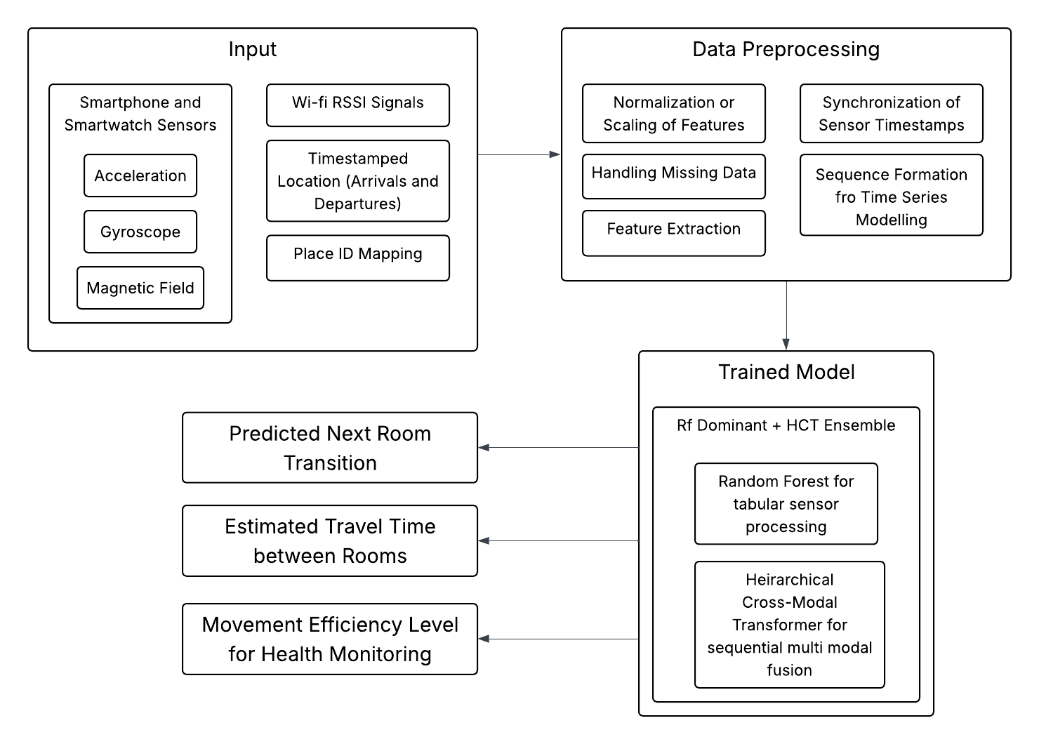

- OUTPUTS AND RESULTS

  - Random Forest Model
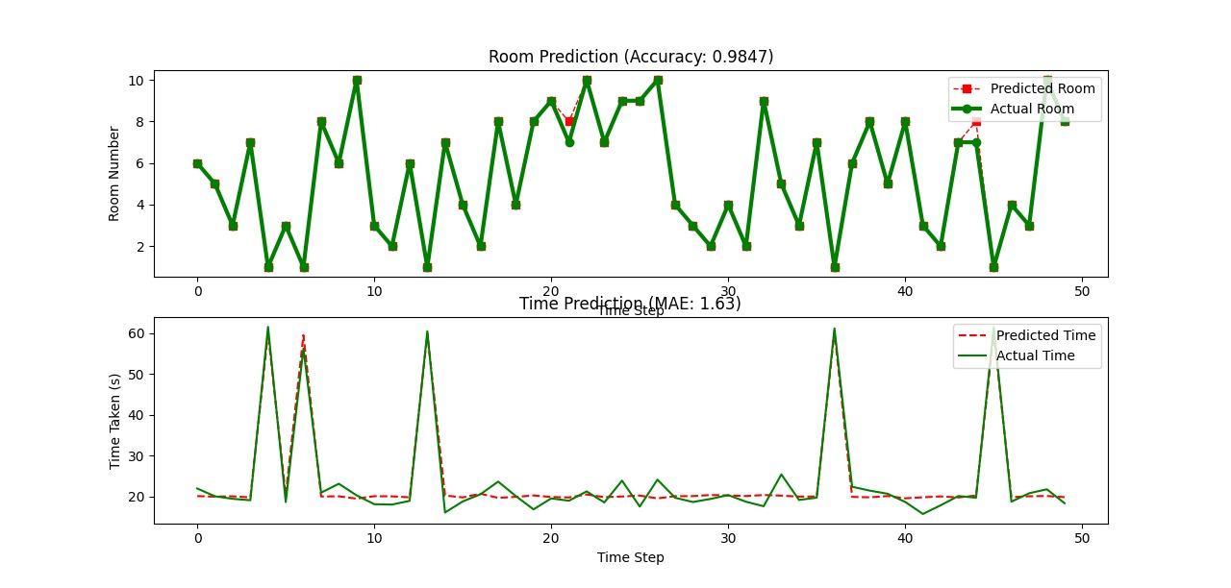

  - Hierarchical Clustering Tree Fusion Model

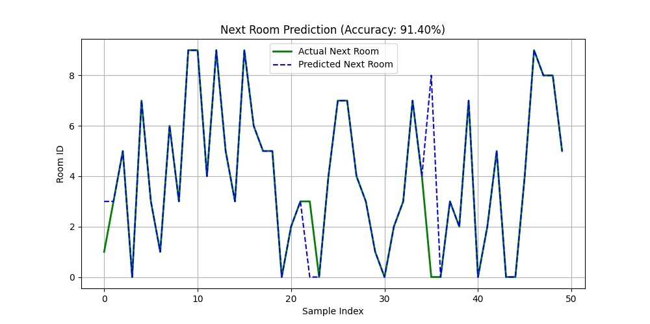

  - Dominant Random Forest + HCT Ensemble Model
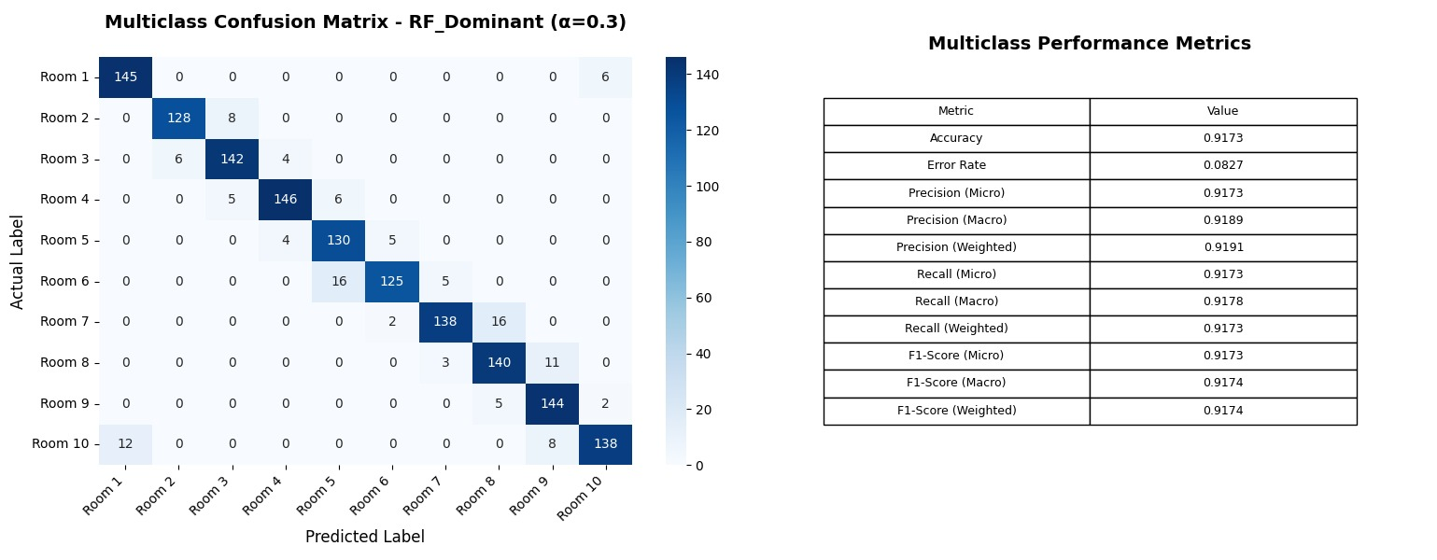

  - Health Monitoring
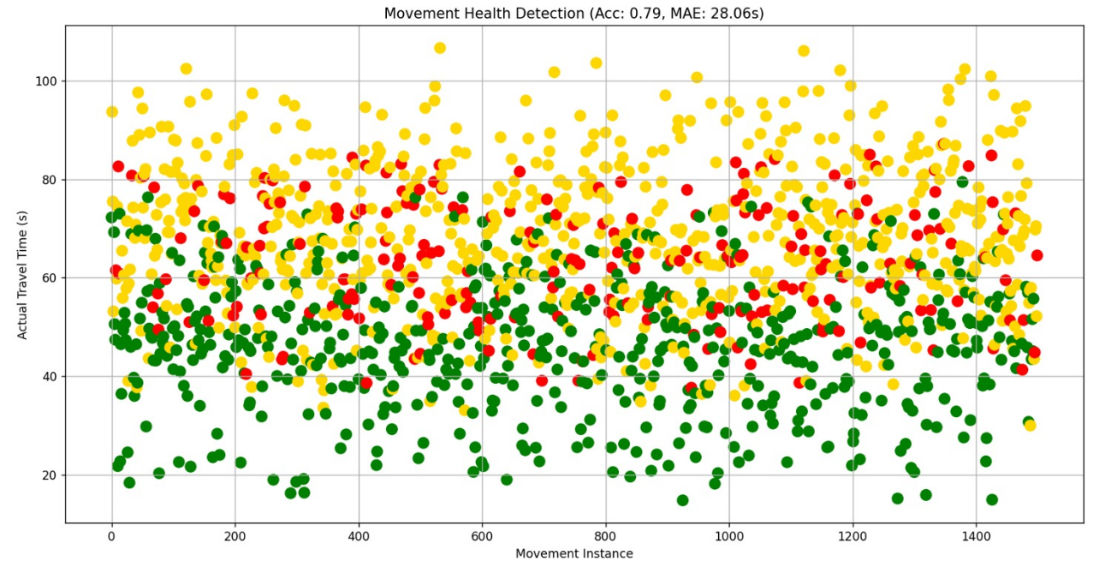

- PSEUDOCODES

    - HCT Fusion

BEGIN

LOAD dataset from 'synthetic_indoor_localization_data.csv'

IF 'Next_Time' column does not exist THEN
GENERATE random realistic durations between 10 and 90 seconds
ADD this as 'Next_Time' column
ENDIF

SEPARATE features (X) from target labels:
X = all columns except ['Timestamp', 'Next_Room', 'Next_Time']
y_room = 'Next_Room' (next location label)
y_time = 'Next_Time' (time tasken to reach next room)

SPLIT dataset indices into training (70%) and testing (30%)

DEFINE CLASS HCTNode:
ATTRIBUTES: indices, left, right, classifier, time_predictor,
depth, is_leaf, prediction
INITIALIZE with given indices and depth

FUNCTION build_hct_node(indices, max_depth=4, min_size=50, depth=0):

CREATE node = HCTNode(indices, depth)

// ----- Stop Conditions -----
IF depth >= max_depth OR number of samples ≤ min_size THEN
node.is_leaf = True
node.prediction = most frequent room in y_room[indices]
RETURN node
ENDIF

// ----- Perform Hierarchical Clustering -----
sub_X = X[indices]
COMPUTE hierarchical linkage using Ward’s method
SPLIT into 2 clusters

left_indices = indices belonging to cluster 1
right_indices = indices belonging to cluster 2

IF either cluster is empty THEN
node.is_leaf = True
node.prediction = most frequent room in y_room[indices]
RETURN node
ENDIF

// ----- Train Classifier for Room Prediction -----
TRAIN RandomForestClassifier on (sub_X, clusters)
STORE classifier in node.classifier

// ----- Train Regressor for Time Prediction -----
sub_y_time = y_time[indices]
TRAIN RandomForestRegressor on (sub_X, sub_y_time)
STORE regressor in node.time_predictor

// ----- Recursively Build Left and Right Subtrees -----
node.left = build_hct_node(left_indices, max_depth, min_size, depth + 1)
node.right = build_hct_node(right_indices, max_depth, min_size, depth + 1)

RETURN node
END FUNCTION

PRINT "Training HCT model..."
root_node = build_hct_node(training_indices)

SAVE root_node as 'hct_model_with_time.pkl'
SAVE test indices as 'test_indices_with_time.pkl'

PRINT "Training complete."

END

    - RF

BEGIN

LOAD dataset from 'synthetic_indoor_localization_data.csv'

IF 'Next_Time' column does not exist THEN
GENERATE random realistic durations between 10 and 90 seconds
ADD this as 'Next_Time' column
ENDIF

SEPARATE features (X) from target labels:
X = all columns except ['Timestamp', 'Next_Room', 'Next_Time']
y_room = 'Next_Room' (next location label)
y_time = 'Next_Time' (time taken to reach next room)

SPLIT dataset indices into training (70%) and testing (30%)

DEFINE CLASS HCTNode:
ATTRIBUTES: indices, left, right, classifier, time_predictor,
depth, is_leaf, prediction
INITIALIZE with given indices and depth

FUNCTION build_hct_node(indices, max_depth=4, min_size=50, depth=0):

CREATE node = HCTNode(indices, depth)

// ----- Stop Conditions -----
IF depth >= max_depth OR number of samples ≤ min_size THEN
node.is_leaf = True
node.prediction = most frequent room in y_room[indices]
RETURN node
ENDIF

// ----- Perform Hierarchical Clustering -----
sub_X = X[indices]
COMPUTE hierarchical linkage using Ward’s method
SPLIT into 2 clusters

left_indices = indices belonging to cluster 1
right_indices = indices belonging to cluster 2

IF either cluster is empty THEN
node.is_leaf = True
node.prediction = most frequent room in y_room[indices]
RETURN node
ENDIF

// ----- Train Classifier for Room Prediction -----
TRAIN RandomForestClassifier on (sub_X, clusters)
STORE classifier in node.classifier

// ----- Train Regressor for Time Prediction -----
sub_y_time = y_time[indices]
TRAIN RandomForestRegressor on (sub_X, sub_y_time)
STORE regressor in node.time_predictor

// ----- Recursively Build Left and Right Subtrees -----
node.left = build_hct_node(left_indices, max_depth, min_size, depth + 1)
node.right = build_hct_node(right_indices, max_depth, min_size, depth + 1)

RETURN node
END FUNCTION

PRINT "Training HCT model..."
root_node = build_hct_node(training_indices)

SAVE root_node as 'hct_model_with_time.pkl'
SAVE test indices as 'test_indices_with_time.pkl'

PRINT "Training complete."

END

    - Health

BEGIN

-----------------------------------------------------
1. DEFINE HCTNode CLASS and Prediction Function
-----------------------------------------------------
DEFINE CLASS HCTNode:
ATTRIBUTES:
indices, left, right, classifier, time_predictor,
depth, is_leaf, prediction

FUNCTION hct_predict(node, x):
IF node is a leaf:
RETURN (node.prediction, None)
ENDIF

# Predict which cluster (left or right) sample belongs to
pred = node.classifier.predict(x)

IF pred == 1:
CALL hct_predict(node.left, x)
ELSE IF pred == 2:
CALL hct_predict(node.right, x)
ELSE:
RETURN (node.prediction, None)
ENDIF

# Predict time to reach next room (if regressor exists)
IF node.time_predictor exists:
time_pred = node.time_predictor.predict(x)
ELSE:
time_pred = None

RETURN (room_pred, time_pred)
END FUNCTION

-----------------------------------------------------
2. LOAD DATA AND MODEL
-----------------------------------------------------
LOAD dataset from 'synthetic_indoor_localization_data.csv'

IF 'Next_Time' column is missing THEN
GENERATE random travel times between 10 and 90 seconds
ADD as new column
ENDIF

SET:
X = feature columns (exclude 'Timestamp', 'Next_Room', 'Next_Time')
y_true_room = actual next rooms
y_true_time = actual travel times

LOAD trained HCT model ('hct_model_with_time.pkl')
LOAD test indices ('test_indices_with_time.pkl')

-----------------------------------------------------
3. EVALUATE MODEL PERFORMANCE
-----------------------------------------------------
FOR each test sample x in X[test_idx]:
(predicted_room, predicted_time) = hct_predict(HCT_model, x)
STORE predicted_room and predicted_time
END FOR

COMPUTE:
- Accuracy = fraction of correctly predicted rooms
- MAE = mean absolute error between true and predicted times

DISPLAY accuracy and MAE

-----------------------------------------------------
4. SIMULATE ACTUAL TRAVEL TIMES
-----------------------------------------------------
ADD random deviation to predicted times to simulate real-world delays
CLIP negative or very small times to minimum of 5 seconds

-----------------------------------------------------
5. HEALTH STATUS DETECTION
-----------------------------------------------------
FOR each pair of (predicted_time, actual_time):
IF predicted_time is missing:
STATUS = "No Prediction"
ELSE IF actual_time ≤ predicted_time + 5:
STATUS = "Normal"
ELSE IF actual_time ≤ 1.5 × predicted_time:
STATUS = "Slight Delay"
ELSE:
STATUS = "Needs Help"
ENDIF
STORE STATUS
END FOR

CREATE table (DataFrame) containing:
Predicted_Room, Actual_Room, Predicted_Time, Actual_Time, Health_Status

SAVE this table as 'person_health_status.csv'

-----------------------------------------------------
6. VISUALIZE HEALTH STATUS
-----------------------------------------------------
CREATE scatter plot:
X-axis: movement instance index
Y-axis: actual travel time
Color-code points by Health_Status:
Green = Normal
Gold = Slight Delay
Red = Needs Help
Gray = No Prediction

DISPLAY plot with title showing Accuracy and MAE

-----------------------------------------------------
7. SUMMARY STATISTICS
-----------------------------------------------------
COUNT number of instances for each Health_Status category
PRINT summary to console

END

    - Ensemble

BEGIN

-----------------------------------------------------
1. ENSEMBLE PREDICTION FUNCTIONS
-----------------------------------------------------
FUNCTION ensemble_predict_room(hct_model, rf_room_model, xgb_room_model, x):
CALL hct_predict(hct_model, x) -> hct_room
CALL rf_room_model.predict(x) -> rf_room
CALL xgb_room_model.predict(x) -> xgb_room

predictions = [hct_room, rf_room, xgb_room]
final_room = majority_vote(predictions)

RETURN final_room, predictions
END FUNCTION

FUNCTION ensemble_predict_time(hct_model, rf_time_model, xgb_time_model, x):
CALL hct_predict(hct_model, x) -> hct_time
CALL rf_time_model.predict(x) -> rf_time
CALL xgb_time_model.predict(x) -> xgb_time

IF hct_time IS NULL THEN
final_time = average(rf_time, xgb_time)
individual_times = [rf_time, rf_time, xgb_time] # RF time reused for HCT placeholder
ELSE
final_time = average(hct_time, rf_time, xgb_time)
individual_times = [hct_time, rf_time, xgb_time]
ENDIF

RETURN final_time, individual_times
END FUNCTION

-----------------------------------------------------
2. LOAD AVAILABLE MODELS
-----------------------------------------------------
CALL find_model_files() -> model_files
FOR each model_type in model_files:
IF model_files[model_type] EXISTS:
LOAD model from file into models dictionary
ELSE:
HANDLE missing model (e.g., fallback to RF models for XGB)
ENDIF
ENDFOR

-----------------------------------------------------
3. LOAD TEST DATA
-----------------------------------------------------
FOR each source in test_data_sources:
TRY loading test data (X_test, y_room_test, y_time_test)
IF success THEN BREAK
ELSE continue
ENDFOR
IF no test data found:
CREATE synthetic test data

-----------------------------------------------------
4. ENSEMBLE PREDICTIONS ON TEST SET
-----------------------------------------------------
INITIALIZE empty lists for ensemble_room_preds, ensemble_time_preds,
individual_room_preds, individual_time_preds

FOR each sample x in X_test:
CALL ensemble_predict_room(models.hct, models.rf_room, models.xgb_room, x) ->
room_pred, indiv_rooms
CALL ensemble_predict_time(models.hct, models.rf_time, models.xgb_time, x) ->
time_pred, indiv_times

ADD room_pred to ensemble_room_preds
ADD time_pred to ensemble_time_preds
ADD indiv_rooms to individual_room_preds
ADD indiv_times to individual_time_preds
ENDFOR

-----------------------------------------------------
5. CALCULATE METRICS
-----------------------------------------------------
CALCULATE ensemble_accuracy, ensemble_precision, ensemble_mae using
y_room_test, y_time_test and ensemble predictions

CALCULATE individual model accuracy and MAE for HCT, RF, XGB using
individual predictions and test targets

-----------------------------------------------------
6. PRINT RESULTS
-----------------------------------------------------
PRINT ensemble and individual model performances
PRINT improvements of ensemble over best individual models

-----------------------------------------------------
7. VISUALIZATION
-----------------------------------------------------
GENERATE confusion matrix plot for ensemble room predictions
GENERATE bar charts comparing accuracies and MAE of models and ensemble
GENERATE pie chart for health status based on ensemble time predictions

SAVE visualization plots to file

-----------------------------------------------------
8. SAVE RESULTS
-----------------------------------------------------
CREATE results table with actual and predicted rooms/times for all models
SAVE results table as CSV
CREATE summary dictionary with timestamp, models used, performances, test set info
SAVE summary as JSON

END

- CONCLUSION
This project successfully created and confirmed a comprehensive indoor localization system which integrates WiFi fingerprinting, geomagnetic field data and inertial sensor data, through a multi-modal ensemble framework. The proposed architecture of HCT-RF Ensemble demonstrates improved performance over traditional single-modality approaches, while achieving reliable room-level prediction abilities with health monitoring functions.
Key outcomes from this research include:
- Improved Localization Accuracy: The RF Dominant ensemble (α=0.3) achieved the best accuracy at 91.73%, while the standalone Random Forest model achieved an exceptional accuracy of 98.47%, both of which significantly exceeded the accuracy of individual HCT models and balanced ensemble configurations.
- Multi-Modal Fusion: The confidence-based fusion approach successfully exploited the complementary strengths of WiFi/sensor data and the use of hierarchical clustering, provided adaptive weighting for reliability in extreme environments.
- Health Monitoring Capabilities in Practice: The system predicted traversal times and observed deviation of expected movement, allowing for real-time assessments of health, and rated user condition as "Normal," "Slight Delay," and "Needs Help," for intervention.
- Robust Temporal Performance: The time prediction mean absolute error (MAE) was slightly higher at 3.74 seconds for the RF Dominant ensemble, versus lower MAE of 1.63 seconds for pure Random Forest, both of which provide an accurate estimate of time for practical application in healthcare and smart building management contexts.
By integrating high spatial accuracy with contextual awareness and health monitoring, the proposed framework's design overcomes the limitations of traditional indoor localization systems. This presents an exciting opportunity for use in medical institutions, assisted living environments, and smart building management systems that require both accurate localization services and monitoring of well-being.
Future research will involve combining visual data from existing CCTV systems to support multimodal fusion for improved accuracy, enhancing the capability of a system that can be used in more complex indoor environments with different user populations.

